

**Advanced**

**Designated**

**Safeguarding**

**Leads**

**August 2020**

There are 12 ADSLs in the City of Nottingham who are available to support Designated Safeguarding Leads and school/academy leaders.

**What do they do?**

The Advanced Designated Safeguarding Lead can:

* Offer advice and guidance on policy and procedure.
* Support newly appointed DSLs during induction.
* Act as a forum for communication and consultation in particular between schools and the Safeguarding Partnership Business Group but also with other partnership bodies.
* Support the functioning of the DSL Network.
* Develop and share evidence based good practice.
* Support a cluster of school DSLs.
* Support training and development.
* Support the Safeguarding Partnership Business Group and schools to undertake audit activity.

**The ADSL team:**

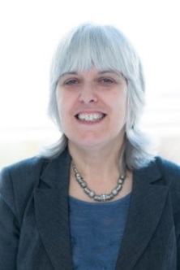

Helen Cast Mel Ennis Stephanie Gray-Blest

Nottingham Girls’ Academy Bluecoat Beechdale Djanogly Strelley Primary

Academy

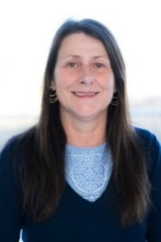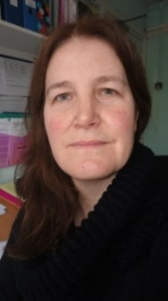

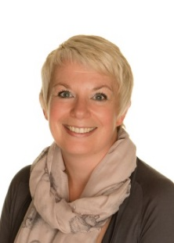

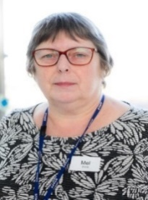

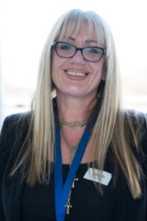

Becky Hyder Jo Lawson Bev Murray

LEAD Academy Trust Forest Fields Primary Raleigh Academy Trust

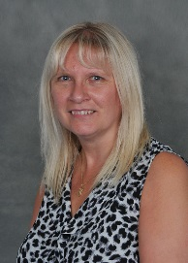

Vic Raynor Alana Watson Joy Smith

Archway Learning Trust Archway Learning Trust Glenbrook Primary

 

Lou Maltby Jo Rowlatt Kim Wenyan

Melbury Primary Southglade Primary Westglade Primary

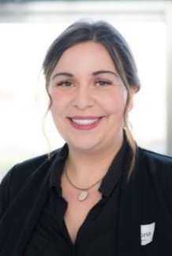

Seth James Hazel McDonald Lorraine Swan

William Booth Primary Claremont Primary Jubilee LEAD Academy

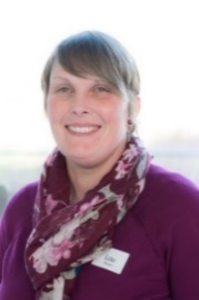

The ADSL team has a range of skills and experiences to support DSLs in schools and academies.

You might request support if you have a new or recently appointed DSL, or for advice on processes and record keeping. Each individual support request will be considered and an ADSL will be deployed.

The ADSLs are be linked to local clusters to support DSLs. The network approach is tailored to each area of the city and will consider local issues, support and share practice.

For more information, visit the [ADSL webpage.](http://bit.ly/2FtQcay)

More DSL information is available on the [DSL webpage.](http://bit.ly/2zAEOem)

Email: [Lisa.Hurst@nottinghamcity.gov.uk](mailto:Lisa.Hurst@nottinghamcity.gov.uk)

Schools and Education Safeguarding Coordinator

**Version 24: August 2020**